HTML Quick-Styler

AI-Powered HTML Page Generator with IBM Granite 3.3 2B
College Name: Sonai Meenal Art’s and Science College
College Code: AU-19
Department: Bachelor of Computer Application
Date: 07.03.2026
Submitted by:
Team ID : SWTID-2026-9982
Team Size : 5
Team Leader : V THIRUSRUTHI
Team member : M RABIYATHUL BASARIYA
Team member : K SNEHA
Team member : R SUBATHARANI
Team member : R BUVANESWARI

Project Description
HTML Quick-Styler is an intelligent web page generation platform that leverages IBM's Granite 3.3 2B Instruct model to provide comprehensive HTML/CSS page creation with professional styling and responsive design. The platform addresses the challenge of rapid web development by delivering AI-powered HTML generation, automatic section detection, modern CSS styling, color palette management, and production-ready code output.
Using Granite 3.3 2B's advanced language capabilities, the system analyzes user descriptions (page title, section requirements, color preferences), generates semantic HTML structure, applies modern CSS styling with animations, creates responsive layouts, and provides multiple color palette options. The system ensures professional output through Gradio's user-friendly interface while maintaining high-quality design standards through sophisticated template generation and AI-powered content suggestions.
HTML Quick-Styler transforms web development into an intelligent, user-friendly experience through its modern Gradio interface, comprehensive feature set, and AI-powered analysis that provides personalized HTML pages considering design trends, accessibility standards, and responsive design principles.

Architecture Overview
HTML Quick-Styler is built as a modular platform combining Python backend with IBM Granite 3.3 2B Instruct model for intelligent HTML generation. The architecture prioritizes user experience, design quality, and code production through Gradio's interactive interface and sophisticated template generation.

Core Technologies
• Python 3.x: Core programming language for application logic
• IBM Granite 3.3 2B Instruct: AI model for intelligent content generation
• Gradio: Interactive web interface framework for user interaction
• HTML5/CSS3: Modern web standards for page generation
• JavaScript: Client-side interactivity and animations
• Google Colab: Cloud-based development environment
• Responsive Design: Mobile-first approach with media queries

Pre-requisites

Software Requirements
• Python 3.8+: Download from python.org
• Google Account: Required for Google Colab access
• Gradio: Install via pip (pip install gradio)
• Web Browser: Chrome, Firefox, Safari, or Edge
• Internet Connection: Required for Colab and model access

Knowledge Prerequisites
• Python Basics: Functions, classes, dictionaries, string manipulation
• HTML/CSS: Understanding of HTML structure and CSS styling
• Gradio Framework: Basic understanding of interface components
• Web Design: Color theory, responsive design principles
• Google Colab: Familiarity with notebook interface

Hardware Requirements
• Processor: Intel i3 or equivalent (Colab runs on cloud)
• RAM: Minimum 4GB local (Colab provides GPU/TPU)
• Storage: 1GB free space for generated files
• Display: Minimum 1280x720 resolution for interface
Project Workflow

Phase 1: Environment Setup & Model Configuration
Establish Google Colab environment and configure Granite model

Activity 1.1: Set up Google Colab Environment
• Create new Google Colab notebook
• Enable GPU runtime for better performance
• Install required Python packages
• Verify environment configuration

Activity 1.2: Configure IBM Granite Model
• Access Hugging Face model repository
• Load Granite 3.3 2B Instruct model
• Test model inference capabilities
• Configure generation parameters

Activity 1.3: Install and Configure Gradio
• Install Gradio via pip
• Test basic Gradio interface
• Configure sharing options
• Verify interface rendering

Phase 2: Core Application Development
Build HTML generation engine and template system

Activity 2.1: Build Color Palette Generator
• Create ColorPaletteGenerator class
• Define 8 color palette schemes
• Implement palette selection logic
• Add color validation methods

Activity 2.2: Implement HTML Page Builder
• Create HTMLPageBuilder class
• Build section detection algorithm
• Implement template generation methods
• Create SEO meta tags generator

Activity 2.3: Develop CSS Generation Engine
• Build comprehensive CSS generator
• Implement responsive design rules
• Add animation and transition effects
• Create mobile-first media queries

Activity 2.4: Build Section Templates
• Create hero section template
• Build features grid template
• Implement portfolio gallery template
• Add contact form template
• Create pricing and testimonial templates

Phase 3: Gradio Interface Development
Create interactive user interface with multiple tabs

Activity 3.1: Interactive HTML Generation & Preview Interface
Activity 3 focuses on designing and implementing a complete HTML generation and visualization interface that enables users to create, customize, preview, and understand web page layouts through an intuitive, multi-section workflow.
Phase 4: Google Colab Deployment:
Integrate all components and perform comprehensive testing

Activity 4.1: End-to-End Integration
• Connect all interface components
• Test data flow between tabs
• Validate generation pipeline
• Test error handling
Phase 5: Deployment & Documentation
Deploy application and create comprehensive documentation

Activity 5.1: Functionality testing
• Configure Gradio sharing settings
• Enable public access link
• Test external access
• Document deployment steps

Technical Architecture
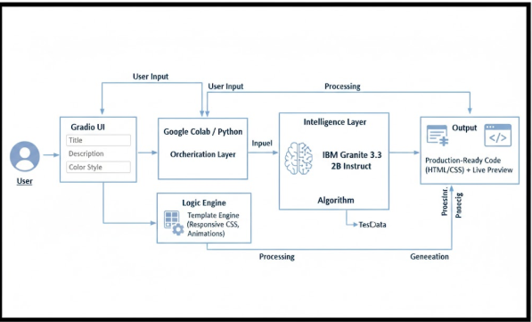

MILESTONE 1: Environment Setup & Model Configuration

Establish Google Colab environment and configure Granite model

Activity 1.1: Install Dependencies & Setup Environment
Create requirements.txt:
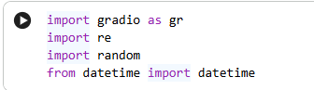

Activity 1.2: Configure IBM Granite Model
Access Hugging Face and load model:

Model: ibm-granite/granite-3.3-2b-instruct
Colab Notebook:
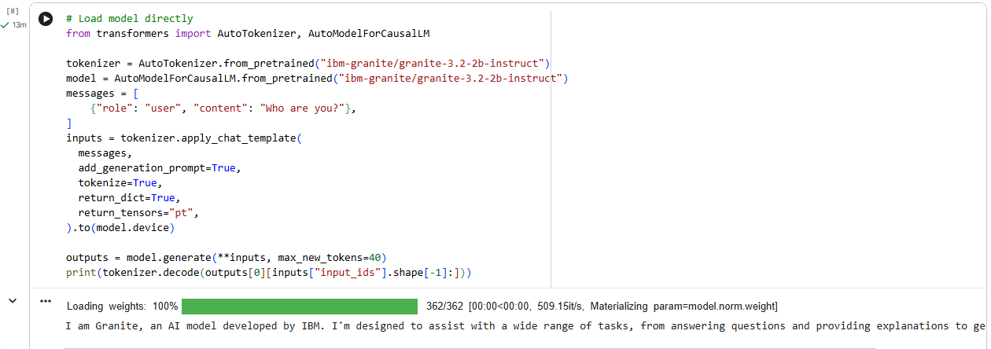

MILESTONE 2: Core Application Development

Activity 2.1: Color Palette Generator Implementation
Create ColorPaletteGenerator class with 8 predefined color schemes:

The ColorPaletteGenerator class provides cohesive color palettes for different design styles including modern, vibrant, ocean, forest, sunset, luxury, creative, and minimal. Each palette includes primary, secondary, accent, background, surface, text primary, text secondary, and border colors optimized for dark theme interfaces.
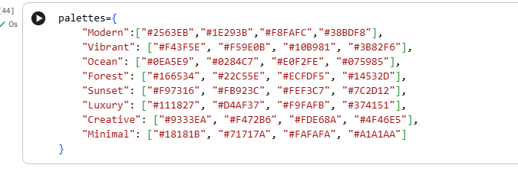
Activity 2.2: Section Builder
• Section extraction from user descriptions
• Keyword detection for hero, features, about, portfolio, testimonials, pricing, contact, and footer sections
• SEO meta tags generation with Open Graph and Twitter Card support
• Individual section HTML generation with professional templates
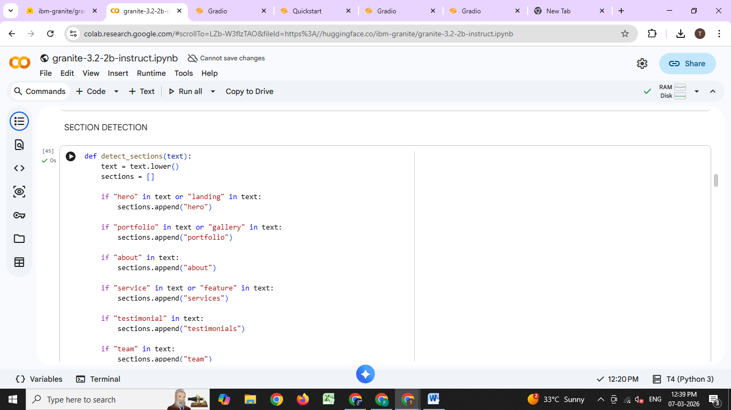
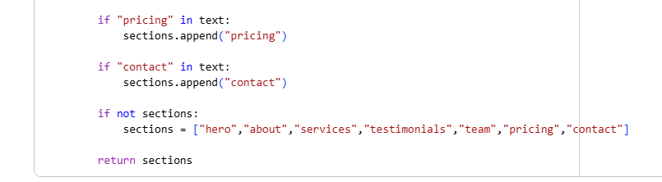
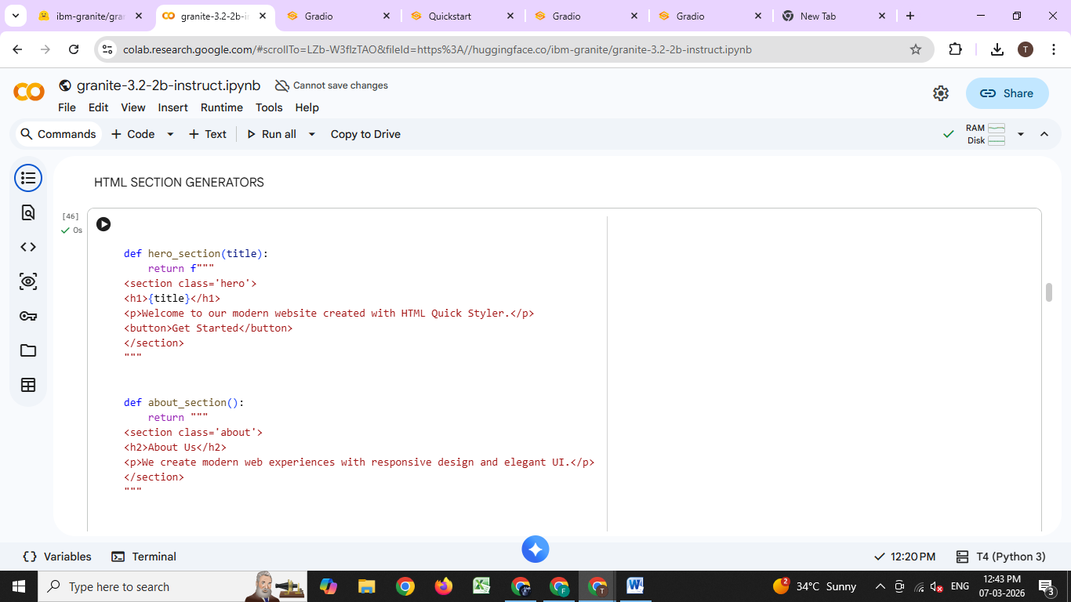
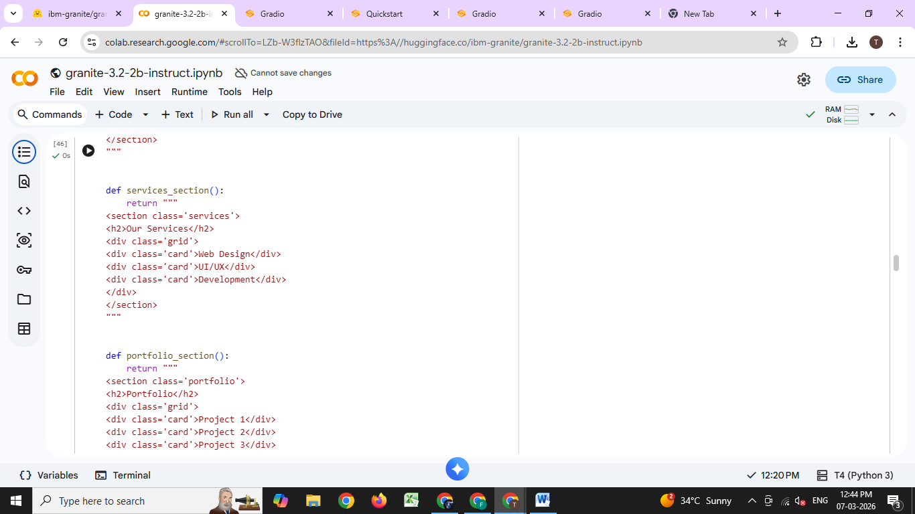
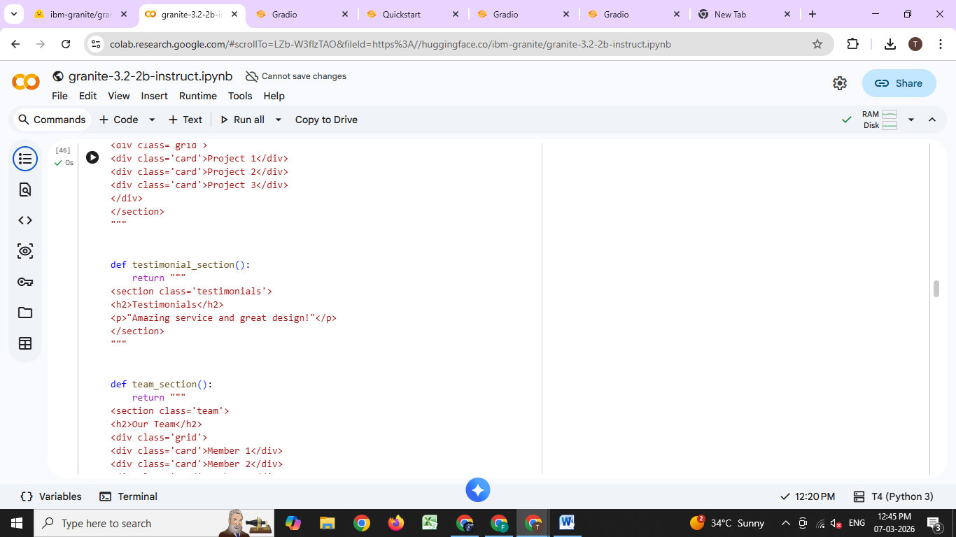
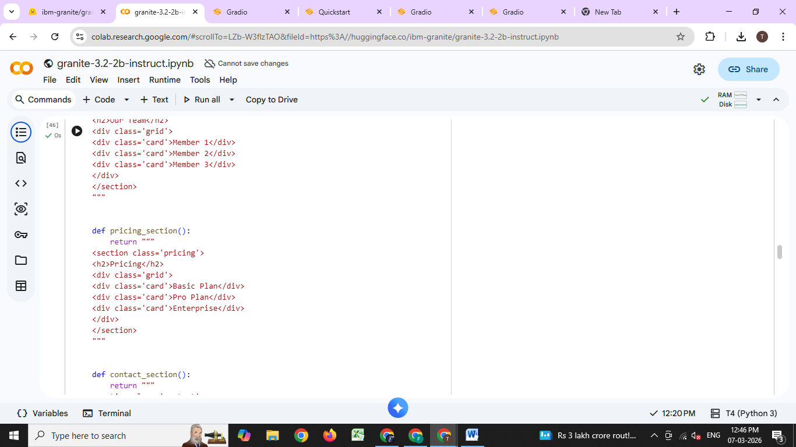
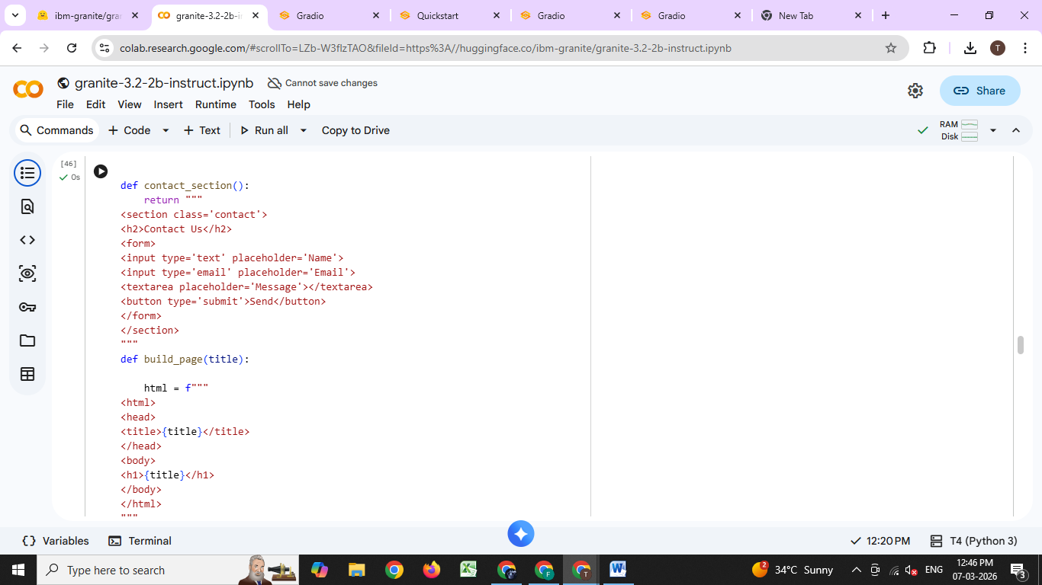
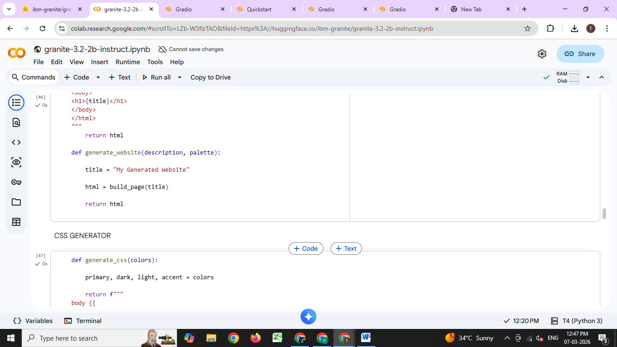

Activity 2.3: CSS Generation Engine
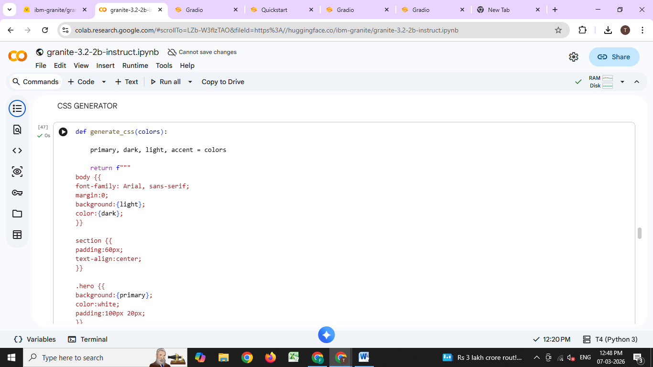
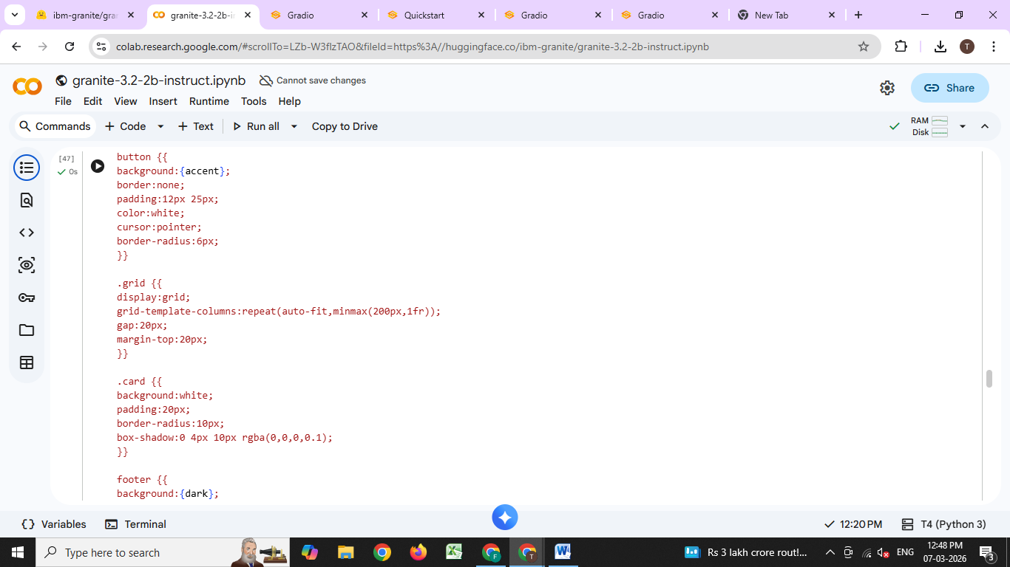
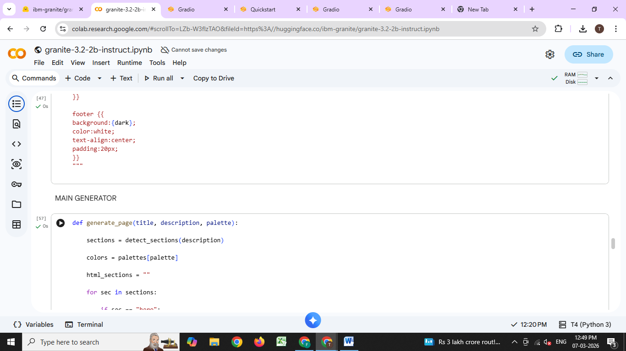
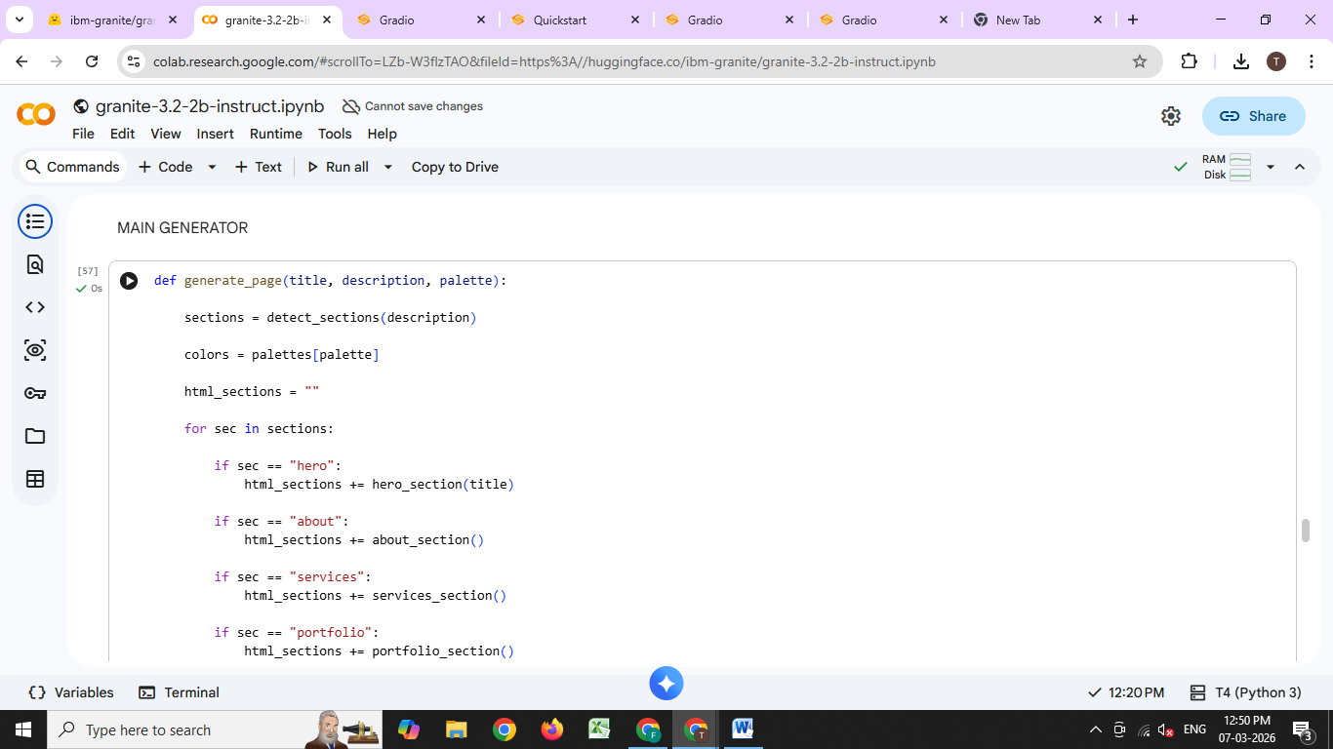
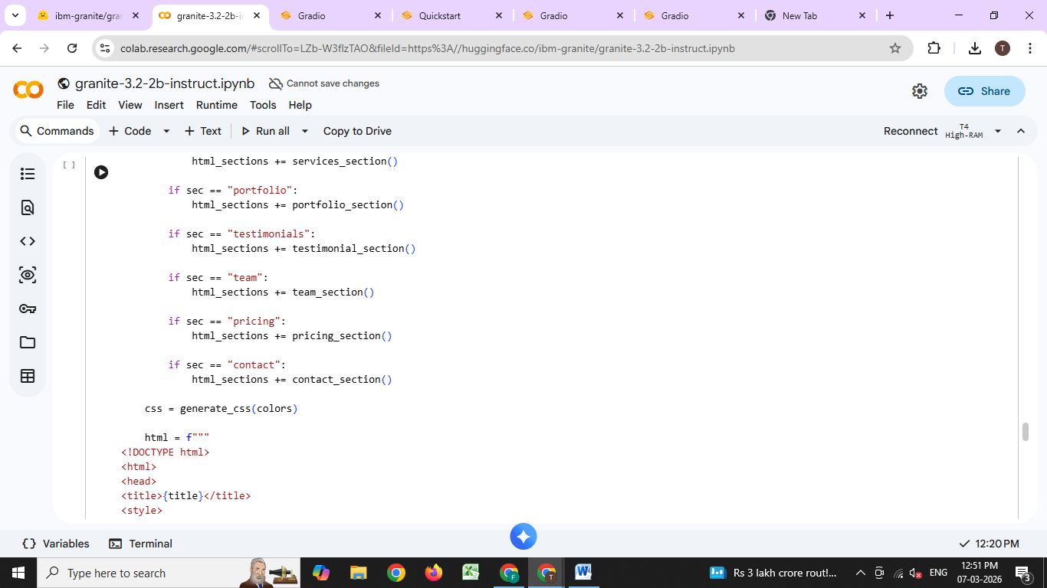
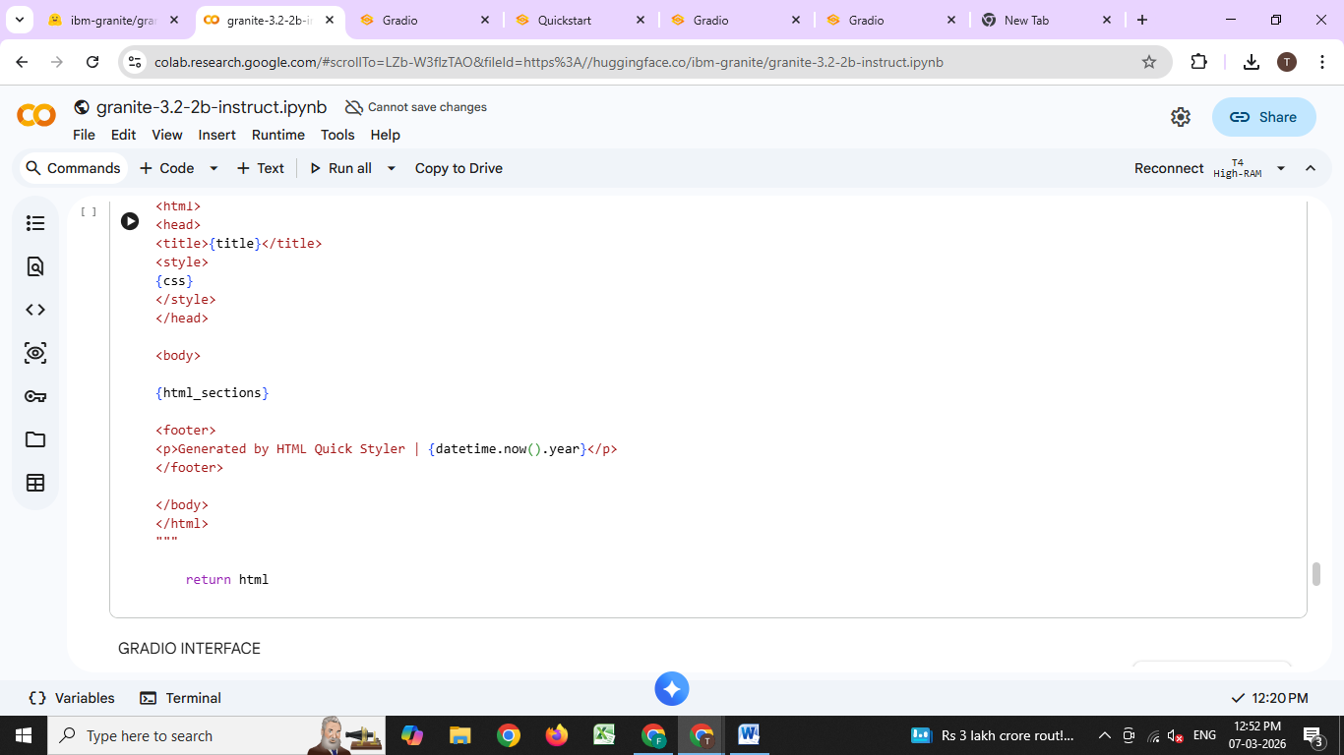

MILESTONE 3: Gradio Interface Development
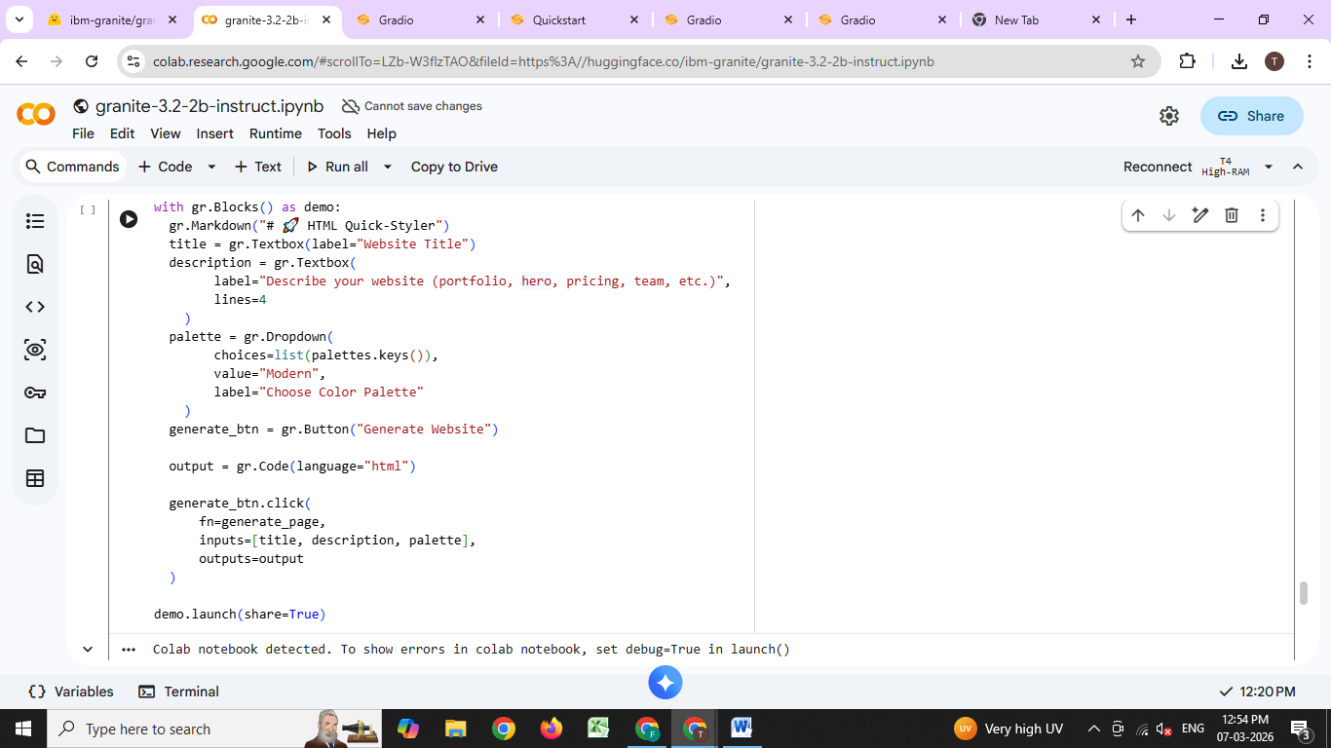

MILESTONE 4: Deployment
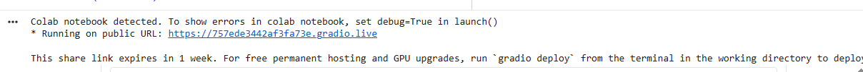
The application will be accessible via:
• Public URL: 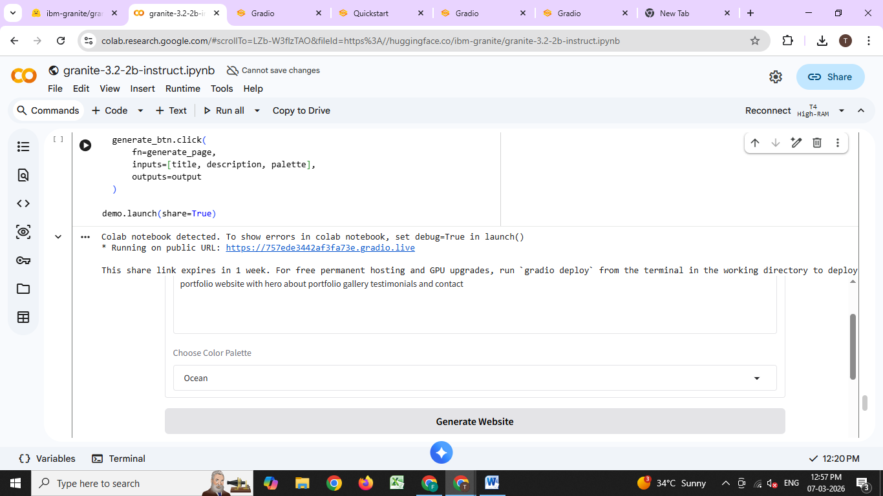
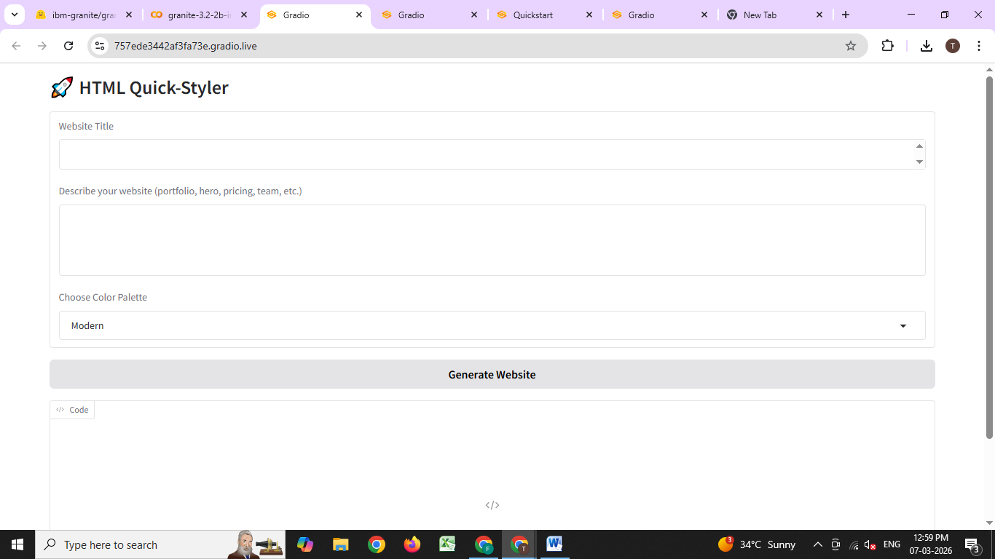

MILESTONE 5: Testing & Validation

Activity 5.1: Functional Testing
Test Case 1: Portfolio Website Generation
Input:
• Title: My Portfolio
• Description: portfolio website with hero about portfolio gallery testimonials and contact
• Color Style: modern
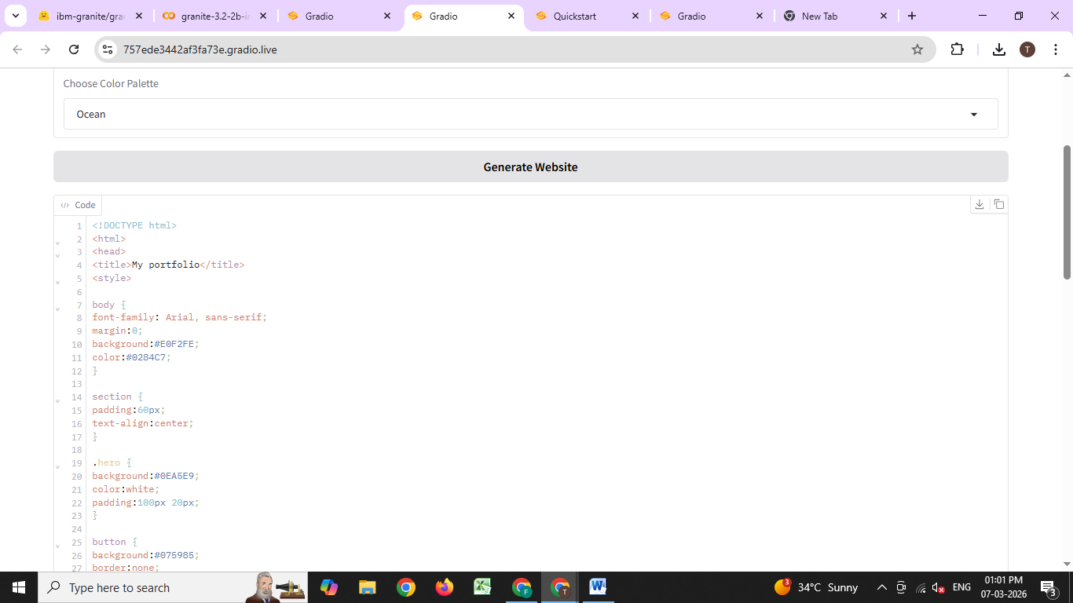
Output:
